**Lab – 34: How to get started with Microsoft Intune in Azure Portal?**

**Objective:** The objective of this lab is –

* To get started with Microsoft Intune in Azure Portal.

The Azure portal is where you can find the Intune service. To get started with Intune in Azure Portal you need to add Intune service in the Azure portal. So, in this lab we are going to add Microsoft Intune in the Azure portal to get started with it.

**Prerequisite:** EMS Enterprise Mobility + Security E5.

**Steps:**

1. Sign in to your Azure Portal, by using the link - **https://portal.azure.com/**. Enter your credentials and click Sign In.

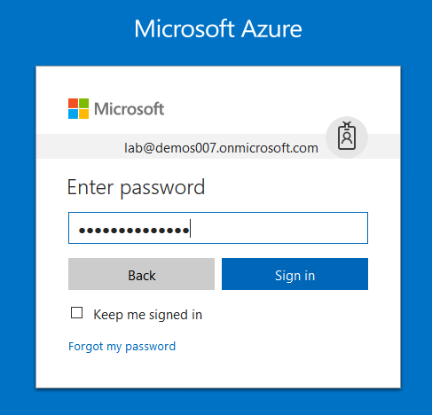

1. If it asks to stay signed in, then you can click Yes or No as per your choice to reduce the number of times you are asked to sign-in.
2. Microsoft Azure AD Dashboard will open.

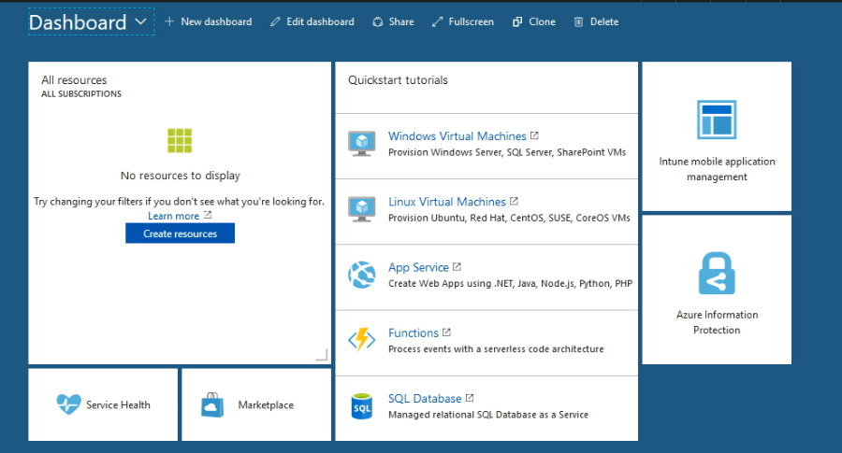

1. Now we are going to add Microsoft Intune on the left side of the Azure portal that shows you a list of all available Azure services.
2. Click **More services** from the bottom of the sidebar on the left side of the page.

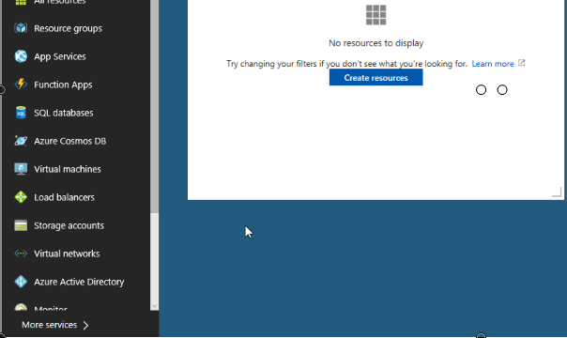

1. Search for **Intune** in the filter box.

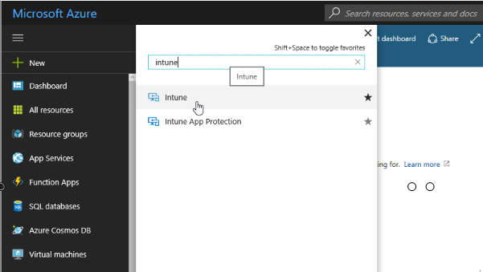

1. Select the star to add Intune to the bottom of the list of your favorite services.

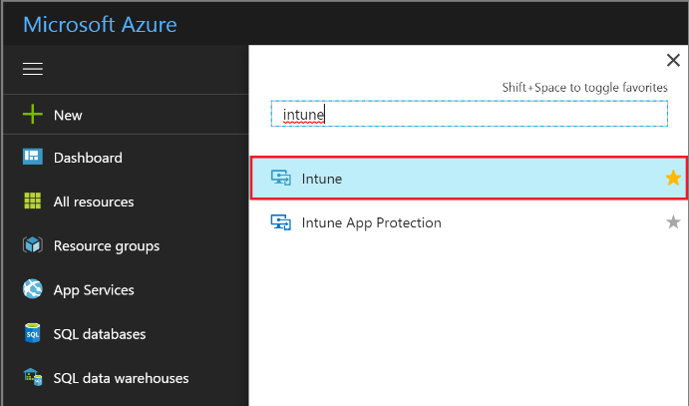

1. Now you can see Intune is added in the list of all available Azure services.

